KUTOVI MNOGOKUTA
59.
a) K_{n}= 2·180°= 360°
b) K_{n}= 3·180°= 540°
c) K_{n}= 7·180°= 1260°
d) K_{n}= 10·180°= 1800°

60.
a) n = 10
K₁₀=(n- 2)·180°=(10 – 2)·180°= 8 ·180° = 1440°

b) n = 15
K₁₅=(n- 2)·180°=(15 – 2)·180°= 13 ·180° = 2340°

c) n = 19
K₁₉=(n- 2)·180°=(19 – 2)·180°= 17 ·180° = 3060°

d) n = 30
K₃₀=(n- 2)·180°=(30 – 2)·180°= 28 ·180° = 5040°

61.
a) d_{n}=n – 3 = 10
n = 13
K₁₃=(n- 2)·180°=(13 – 2)·180°= 11 ·180° = 1980°

b) d_{n}=n – 3 = 15
n = 18
K₁₈=(n- 2)·180°=(18 – 2)·180°= 16 ·180° = 2880°

c) d_{n}=n – 3 = 19
n = 22
K₂₂=(n- 2)·180°=(22 – 2)·180°= 20 ·180° = 3600°

d) d_{n}=n – 3 = 3
n = 6
K₆=(n- 2)·180°=(6 – 2)·180°= 4 ·180° = 720°

62.
a) K_{n}=1080°
(n- 2)·180°=1080° / : 180
n – 2 = 6
n = 8

b) K_{n}=3240°
(n- 2)·180°=3240° / : 180
n – 2 = 18
n = 20

c) K_{n}=2160°
(n- 2)·180°=2160° / : 180
n – 2 = 12
n = 14

d) K_{n}=4500°
(n- 2)·180°=4500° / : 180
n – 2 = 25
n = 27

63.
a) K_{n}=1350°
(n- 2)·180°=1350° / : 180
n – 2 = 7.5
n = 9.5
Ne može jer n mora biti prirodan broj.

b) K_{n}=2320°
(n- 2)·180°=2320° / : 180
n – 2 = 12.89
Ne postoji jer n nije prirodan broj.

c) K_{n}=2520°
(n- 2)·180°=2520° / : 180
n – 2 = 14
n = 16
Postoji.

d) K_{n}=560°
(n- 2)·180°=560° / : 180
n – 2 = 3.11
Ne postoji.
64.
a) n = 8
K₈=(n- 2)·180°=(8 – 2)·180°= 6 ·180° = 1080°

b) d_{n}= n – 3 = 12
n=15
K₁₅=(n- 2)·180°=(15 – 2)·180°= 13 ·180° = 2340°

c) $D_{n}=27$
$\frac{n\left(n-3\right)}{2}=27$
n(n – 3)=54
9(9-3) = 54
n = 9
K₉=(n- 2)·180°=(9 – 2)·180°= 7 ·180° = 1260°

65.
K_{n}=4· K'_{n}
(n- 2)·180° = 4 ·360° / : 180°
n – 2 = 8
n = 10
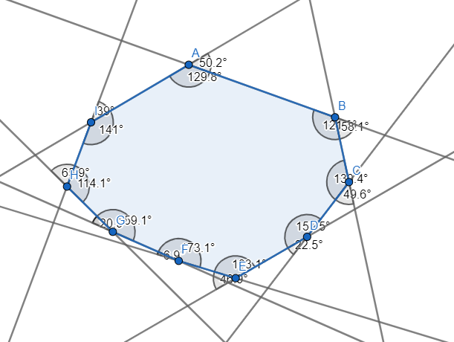
66.

67.
a) n = 7
K₇=(n- 2)·180°=(7 – 2)·180°= 5 ·180° = 900°

b) n = 17
K₁₇=(n- 2)·180°=(17 – 2)·180°= 15 ·180° = 2700°

c) n = 23
K₂₃=(n- 2)·180°=(23 – 2)·180°= 21 ·180° = 3780°

d) n = 25
K₂₅=(n- 2)·180°=(25 – 2)·180°= 23 ·180° = 4140°

68.
a) n = 13
K₁₃=(n- 2)·180°=(13 – 2)·180°= 11 ·180° = 1980°

b) n = 27
K₂₇=(n- 2)·180°=(27 – 2)·180°= 25 ·180° = 4500°

c) n = 29
K₂₉=(n- 2)·180°=(29 – 2)·180°= 27 ·180° = 4680°

d) n = 48
K₄₈=(n- 2)·180°=(48 – 2)·180°= 46 ·180° = 8280°

69.
a) dn =n – 3 = 7
n=10
K₁₀=(n- 2)·180°=(10 – 2)·180°= 8 ·180° = 1440°

b) dn =n – 3 = 17
n=20
K₂₀=(n- 2)·180°=(20 – 2)·180°= 18 ·180° = 3240°

c) dn =n – 3 = 23
n=26
K₂₆=(n- 2)·180°=(26 – 2)·180°= 24 ·180° = 4320°

d) dn =n – 3 = 25
n=28
K₂₈=(n- 2)·180°=(28 – 2)·180°= 26 ·180° = 4680°

70.
a) 4 ·180° = 720°
b) 6 ·180° = 1080°
c) 8 ·180° = 1440°
d) 15 ·180° = 2700°

71.
a) $K_{18}+K_{18}^{'}=18∙180°=3240°$
b) $K_{20}+K_{20}^{'}=20∙180°=3600°$

72.$K_{n}+K_{n}^{'}=n∙180°=3060°$
n = 3060 : 180
n= 17
To je 17-terokut.

73.
a) K₄=(n- 2)·180°=(4 – 2)·180°= 2 ·180° = 360°
α=360° - 81°43'-86° - 110°58 ' =81°19'

b) K₅=(n- 2)·180°=(5 – 2)·180°= 3 ·180° = 540°
β=540° - 92°- 102°-125° - 115° = 106°

c) K₆=(n- 2)·180°=(6 – 2)·180°= 4 ·180° = 720°
γ=720° - 90°- 130°27' -134° - 107° -120°= 138°33'

d) K₇=(n- 2)·180°=(7 – 2)·180°= 5 ·180° = 900°
δ =900° - 143°- 121° -126° - 130° -148° - 96°= 136°

74.
K₈=(n- 2)·180°=(8 – 2)·180°= 6 ·180° = 1080°
1080° - 133°- 118° - 137° - 127° - 140° - 149° - 151° = 125°
Preostali kut je 125°.

75.
K₆=(n- 2)·180°=(6 – 2)·180°= 4 ·180° = 720°
720° - 105°48'- 138°29' - 157° - 154° - 81° = 83°43'
Preostali kut je 83°43'.
76.
4x + 72°= K₅
4x + 72 = 540
4x = 540 – 72
4x =468 / : 4
x = 117
Veličina je 117°.

77.
(n- 2)·180°=2 520° / :180°
n – 2 = 14
n = 16
16 – terokutu.

78.
a) (n- 2)·180°=540° / :180°
n – 2 = 3
n = 5
5 vrhova.

b) (n- 2)·180°=1620° / :180°
n – 2 = 9
n = 11
11 vrhova.

c) (n- 2)·180°=1980° / :180°
n – 2 = 11
n = 13
13 vrhova.

d) (n- 2)·180°=2880° / :180°
n – 2 = 16
n = 18
18 vrhova.

e) (n- 2)·180°=3060° / :180°
n – 2 = 17
n = 19
19 vrhova.

f) (n- 2)·180°=4680° / :180°
n – 2 = 26
n = 28
28 vrhova.

79.
K₄=(4-2)·180°= 360°
2x + 2(x + 20°)= 360°
2x + 2x + 40°=360°
4x=320°
x= 80°
2 kuta imaju veličinu 80°, a druga dva po 100°.

80.
a) $K_{n}+K_{n}^{'}=n∙180°=540°$
n = 540 : 180
n = 3
D₃=0

b) $K_{n}+K_{n}^{'}=n∙180°=900°$
n = 900 : 180
n = 5
$D_{5}=\frac{n\left(n-3\right)}{2}=\frac{5\left(5-3\right)}{2}=5$

c) $K_{n}+K_{n}^{'}=n∙180°=1080°$
n = 1080 : 180
n = 6
$D_{6}=\frac{n\left(n-3\right)}{2}=\frac{6\left(6-3\right)}{2}=9$

d) $K_{n}+K_{n}^{'}=n∙180°=1620°$
n = 1620 : 180
n = 9
$D_{9}=\frac{n\left(n-3\right)}{2}=\frac{9\left(9-3\right)}{2}=27$

81.
a) (n- 2)·180°=980° / :180°
n – 2 = 5.444..
Ne postoji.
b) (n- 2)·180°=1260° / :180°
n – 2 = 7
n = 9
Postoji.

c) (n- 2)·180°=2460° / :180°
n – 2 = 13.666…
Ne postoji.

d) (n- 2)·180°=3560° / :180°
n – 2 = 13.777…
Ne postoji.

82.
$$K_{n}-K_{n}^{'}=\left(n-2\right)∙180°-360°=\left(n-2\right)∙180°-2·180°=180°\left(n-2-2\right)=(n-4)·180°$$
n - 4 = 1260 : 180
n - 4= 7
n=11

83.
$$K_{n}=14K_{n}^{'}$$
$\left(n-2\right)∙180°=14∙360°$ / : 180°
n-2 = 28
n=30

DOPUNSKI ZADACI

86.
$K_{3}=\left(n-2\right)∙180°=\left(3-2\right)∙180°=180$°

87.
$$K_{4}=\left(n-2\right)∙180°=\left(4-2\right)∙180°=2∙180°=360°$$

88.
$$K_{5}=\left(n-2\right)∙180°=\left(5-2\right)∙180°=3∙180°=540°$$

89.
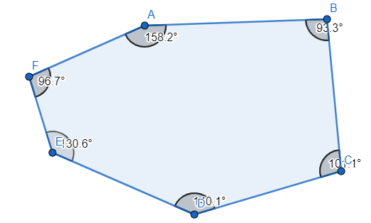

$$K_{6}=\left(n-2\right)∙180°=\left(6-2\right)∙180°=4∙180°=720°$$
Zbrojene veličine daju 720°.

DODATNI ZADACI
91.
$\left(n-2\right)∙180°=2340°$ /:180
n – 2 = 13
n = 15
15x = 2340° /:15
x= 156°
Svaki kut je veličine 156°.

92.
n=360° : 24° = 15
$D_{9}=\frac{n\left(n-3\right)}{2}=\frac{15\left(15-3\right)}{2}=90$

93.
K_{n}=11 ·180°=1980°
n – 2 = 11 n = 13
$D_{13}=\frac{n\left(n-3\right)}{2}=\frac{13\left(13-3\right)}{2}=65$

94.
a)
dn = n – 3
n – 3 = 21
n = 24
$$K_{24}=\left(n-2\right)∙180°=\left(24-2\right)∙180°=22∙180°=3960°$$

b)
21 dužina iz jednog vrha
2 stranice + 19 dijagonala
n – 3 = 19
n = 22
$$K_{22}=\left(n-2\right)∙180°=\left(22-2\right)∙180°=20∙180°=3600°$$
95. x – vanjski kut
$$K_{n}+x=2005°$$
$$K_{13}=\left(n-2\right)∙180°=\left(13-2\right)∙180°=11∙180°=1980°$$
x = 2005° - 1980°
x = 25°
Trinaesterokut.

96.
x – unutarnji kut
$$K_{n}'+2x=672°$$
$$360°+2x=672°$$
2x = 672° - 360°
2x = 312°
x=156°

156°·n + 360°=n·180°
156n – 180n = - 360
-24n = - 360 / : -24
n = 15
Petnaesterokut.

